

American International University-Bangladesh (AIUB)

# Thesis

## Using AR technology in Bangladesh Map to represent Bangladesh’s historical places

**Submitted by:**

|  |  |
| --- | --- |
| **Shanzida Afroza Shatu** | **17-34583-2** |
| **Jannatul Ferdoush** | **17-34608-2** |
| **Md. Atik Hasan** | **17-35834-3** |
| **Md. Dipu Hasan** | **18-36364-1** |

## Department of Computer Science Faculty of Science & Technology

**American International University-Bangladesh September 2021**

Declaration

We certify that this thesis is our original work. No part of this has been submitted elsewhere partially or fully for the award of any other degree. Any material reproduced in this thesis has been properly acknowledged. We declare that this thesis does not contain any content that discloses the secret of any organization or related parties. American International University- Bangladesh (AIUB) will not be held liable for any such activity, as for the thesis is presented as our original work.



|  |  |
| --- | --- |
| Name: Shanzida Afroza Shatu Id: 17-34583-2  Department of Computer Science | Name: Jannatul Ferdoush Id: 17-34608-2  Department of Computer Science |
| Name: Md. Atik Hasan Id: 17-35834-3  Department of Computer Science | Name: Md. Dipu Hasan Id: 18-36364-1  Department of Computer Science |

Approval

This thesis titled “Using AR technology in Bangladesh Map to represent Bangladesh’s historical places**”** has been submitted to the following respected member of the board of Examiners of the faculty of Science and Information Technology Impartial fulfillment of the requirements for the degree of Bachelor of Science in Computer Science and Engineering on September 21, 2021 and has been accepted satisfactory.

|  |  |  |
| --- | --- | --- |
| **DR. MD. ABDULLAH –AL-JUBAIR**  Assistant Professor and Supervisor Department of Computer Science  American International University-Bangladesh |  | **MD. KISHOR MOROL**  Lecturer and External Department of Computer Science  American International University-Bangladesh |
| **DR. MD. MAHBUB CHOWDHURY MISHU**  Head (Undergraduate Program) Department of Computer Science  American International University-Bangladesh |  | **DR. TAFAZZAL HOSSAIN**  Dean  Faculty of Science and Technology  American International University-Bangladesh |
| **DR. CARMEN Z. LAMAGNA**  Vice Chancellor  American International University-Bangladesh | | |

Acknowledgement

This Thesis is our cordial effort and our supervisor’s initiative and constant motivation. But first, we would like to be grateful to the Almighty Allah, who gives us the effort to work on this thesis for the last one semester. Especially thanks go to our honorable supervisor Dr. Md. Abdullah-Al-Jubair, American International University-Bangladesh [AIUB] for his enormous support, inspiration, and helpful criticism. His excellent supervision and constant support make this thesis possible. We are very grateful to him for giving us the opportunity to work with him. We also convey our thanks to our honorable Vice Chancellor, Dr. Carmen Z. Lamagna, our Dean, Prof. Dr. Tafazzal Hossain, our Associate Dean, Mashiour Rahman, our Director, Dr. Dip Nandi, and our Head of Department Dr. Mahbub Chowdhury Mishu for their constant motivation and support.

Finally, yet importantly, we thank our respectable parents for educating us with aspect from both arts and sciences, for their unconditional support and encouragement to pursue out interests, even when interests went out of boundary.

### Abstract

Augmented Reality (AR) is the integration of real-world objects with real-time use of information in the form of text, graphics, audio and other virtual enhancement. Tourism sector is a booming sector in Bangladesh. To boost up the tourism sector of our country, mobile augmented system can bring a revolutionary change. When tourists want to know the details of the historical place of Bangladesh, it will show the desired video and 3D model on their mobile screen. As a result, tourists will be encouraged to visit these places. An Augmented Reality based map was developed in this study to enhance the tourism sector and to know the usefulness of mobile AR system. Mobile Augmented Reality for Android Smartphone’s will encourage and enlighten tourists around the world about the Bangladeshi cultural heritage and rich history. We have used Vuforia as tracking library and Unity Game Engine to integrate the system. For developing the application, we have used the Software Development Life Cycle (SDLC) model. For the testing, a questionnaire was used to evaluate the user’s satisfaction by throwing two questions on Google form. From the evaluation report, we acknowledged that the application meets its expectations, and user’s feedback was satisfactory. To sum up, the mobile AR system was implemented successfully and could be upgraded with new features and should keep on maintenance.

**Keywords**: Augmented Reality, Target Image, Integration, Vuforia, Unity, Effectiveness.

**Table of Contents**

**Topics**

DECLARATION… ii

APPROVAL iii

ACKNOWLEDGEMENT iv

ABSTRACT v

CHAPTER 1: INTRODUCTION

* 1. Overview 1
  2. Background Study 2-5
  3. Motivation of the Study 5
  4. Problem Statement 6
  5. Research Objective 6
  6. Contribution of the Study 7
  7. Summary 7

CHAPTER 2: LITERATURE REVIEW

* 1. Overview 8
  2. Augmented Reality 8-13
  3. Tracking and Image Processing 13
  4. Augmented Reality SDK Framework 13
     1. Overview of Vuforia as Tracking Library 13
     2. Overview of ARToolkit+ as Tracking Library 14
     3. Overview of ARKit as Tracking Library 15
  5. Graphics and Multimedia Generation 16
     1. Overview of Unity as 2D/3D Graphics 16
     2. Overview of OpenGL 17
  6. Basic Applications of Unity 3D & Vuforia in AR 18
  7. Related Work 19-21
  8. Summary 21

CHAPTER 3: METHODOLOGY

* 1. Overview 22
  2. Research Methodology 22
     1. Framework 22-23
  3. System Development Methodology 24
     1. Planning… 25
     2. Designing 26
     3. Coding 27
     4. Evaluation and Testing 28
     5. Maintenance 28
  4. Work Planning and Execution 29
  5. Budget 29
  6. Summary 29

CHAPTER 4: IMPLEMENTATION AND EVALUATION

* 1. Overview 30
  2. Framework 30
  3. System Flow 31
  4. Implementation
     1. Vuforia Tracking Library 32
     2. Video Capture 33
     3. Tracking 34
     4. 2D and 3D Integration 35
  5. Evaluation 35
     1. Participants 35
     2. Finding the Effectiveness 35-37
  6. Findings 37-38
  7. Summary 38

CHAPTER 5: CONCLUSION

* 1. Overview 39
  2. Summary of the Background Study 39
  3. Summary of the Study Objective 39-40
  4. Summary of Methodology 40
  5. Summary of Implementation 40
  6. Summary of Evaluation and Result 40-41
  7. Summary of Findings 41
  8. Significance of the Study 41
  9. Limitation and Future Work 42
  10. Summary of the Study 42-43

**REFERENCES** 44-47

#### List of Figure

Figure 1.1 Reality-Virtuality Continuum 2

Figure 1.2 Parts of three-dimensional Display System 3

Figure 1.3 Augmented Reality Map… 5

Figure 2.1 Real desks with virtual lamp & two virtual chairs 9

Figure 2.2 Optical see-through HMD conceptual diagrams 9

Figure 2.3 Evaluation of Mobile AR 10

Figure 2.4 Flow chart of Simultaneous Localization and Mapping 11

Figure 2.5 Depth Tracking 12

Figure 2.6 Image Processing and Projection 13

Figure 2.7 Vuforia AR SDK 14

Figure 2.8 ARToolKit+ AR SDK 15

Figure 2.9 ARkit AR SDK 16

Figure 2.10 Unity as 2D/3D Graphics 17

Figure 2.11 OpenGL 18

Figure 2.12 Unity 3D and Vuforia in AR 19

Figure 3.1 Conceptual Framework of an AR System 22

Figure 3.2 Flowchart of the System 23

Figure 3.3 System Development Life Cycle 25

Figure 3.4 Planning 26

Figure 3.5 Requirement Gathering & Analysis 27

Figure 3.6 Development & Implementation 27

Figure 3.7 Testing 28

Figure 3.8 Deployment 28

Figure 3.9 Gantt chart 29

Figure 4.1 Flow chart of Architecture of the system 30

Figure 4.2 System Flow of Augmented Reality based Bangladesh’s Map 31

Figure 4.3 Vuforia Tracking Library 32

Figure 4.4 Snapshot of the script of video capture for Android Device 33

Figure 4.5 Snapshot of the script of Tracking 34

Figure 4.6 Sample pictures of 2D and 3D video capturing 35

Figure 4.7 Pie-Chart-1 36

Figure 4.8 Pie-Chart-2 37

#### List of Tables

Table 2.1 Vuforia Tracking 14

Table 3.5 Budget 29

### Overview

# Chapter-1 Introduction

The advancement of Augmented Reality (AR) technology provides a latest way to guide students by enhancing the quality of instructing and learning experiences (Nincarean, Ali, Halim & Rahman, 2013). Computer graphics objects are merged with the actual picture that distributes to the AR and VR technology (Azuma, 1997).Virtual Reality (VR) such as 2D, 3D, animation, text or audio-visuals can be superimposed on the user interface corresponding to the unique markers with the aid of Augmented Reality (Azuma, 1997).

Maps represent information about the world in a simple and easy way. It provides us information to identify places and locations in a region that helps to find from one place to another. Maps appear for the real world on a much compact scale. Map is a major part of our day to day lives. We utilize it for driving directions. There are more uses of maps such as we can obtain information that where is the specific country or city. People find it difficult to calculate country’s local time with regard to Greenwich Meantime (GMT). Tourist maps carry out numerous functions most important of which are: supplying information for their users about tourist location, geographical space and going around the area, making the choice of the visited tourist area and in planning the journey. Here’s how map reading helps us while travelling to and within a brand new place such as avoids confusion, saves time, better safety etc. An interactive map will help the users to navigate safely. Proper informative map will reduce the wastage of time while visiting an unknown place. The widespread use of mobile devices by integrating AR technologies is now growing rapidly which reflects the increase of handheld devices in recent years across the world (Nincarean et al., 2013).

The purpose of this study is to design an Augmented Reality framework system by using Bangladesh’s map in handheld devices. By applying Augmented Reality technology in our map, we will be able to detect eight divisions and can visualize the information of these divisions. . The system will be designed for tourist spot that can provide information of the tourist place through 3D animation. The main goal of this study is to find out the effectiveness of AR based Bangladesh Map by conducting a survey to know about Bangladesh properly.

### Background Study

Augmented reality (AR) technology is the modern phase of virtual reality (VR) that combines with the simulation data of computer in a actual surroundings (Yovcheva et al., 2012). The visualization techniques which convergent computer generated data onto the real world view by capturing from the electronic devices (mobile phone, computer and other devices) are commonly referred to as Augmented Reality. The main aim of AR is to enhance user’s view of the world that merges digital information by improving the ability to overlay virtual objects on the real world (Billinghurst, 2002). Virtual Reality (VR) can be used as computer technology to interact with a simulated environment. 3D and visuals are commonly connected with this technology (Dadwal & Hassan, 2015). A commonly known concept of ‘Mediated Reality’ is related to AR where real view is altered, augmented by a computer (Hassan & Ramkissoon, 2016). The adjacency of user’s perception of the actual world turns digitally interdependent by the advancement of AR technology with computer vision and object detection techniques by simulating information (Hassan & Ramkissoon, 2016). The history of Augmented Reality moves back to 1960s and both AR and VR were used as the first system (Johnson et al., 2010). Ivan Sutherland first created the augmented reality device called ‘The Sword of Damocles’ in 1968 (Billinghurst et al., 2014). Two different methods: a mechanical tracker and an ultrasonic tracker were used in an optical see-through head-mounted display. At that time, as processing power was less, the manageable layout of computing system was possible in actual time (Sutherland, 1968).

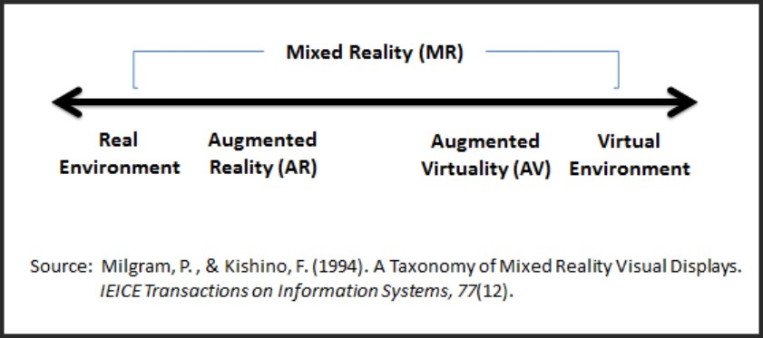

#### Figure 1.1: Reality-Virtuality (VR) Continuum

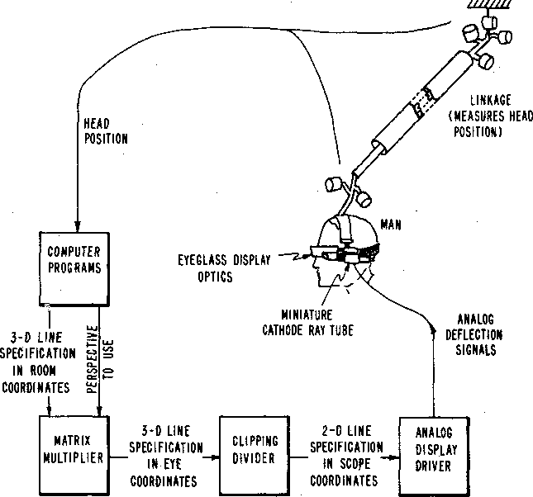

**Figure 1.2: The parts of three-dimensional display system**

Liarokapis et al. (2004) demonstrated their work to develop an educational application with the combination of 3D Web Content (Web3D) which has benefits in the educational sector. Hassan & Ramkissoon (2016) described their work to develop an Augmented Reality based technology in tourist destinations across the world to improve visitor’s experiences through newly developed interactive libraries. Many professionals and analyzers have been evolving practical knowledge and application of AR in different sectors during the last few decades. Students can enlarge their learning’s of complicated lessons in higher education which will be beneficial to their future progress. Liarokapis et al., (2004) found that complex theories and mechanisms can be easily understandable and acceptable by students with emerged interaction using the Augmented Reality (AR) technology. AR can be implemented as an interactive tool in tourist spots by introducing visitors the actual taste of the spots and notifying travelers of attractive places with 3D animations. In the field of manufacturing field, AR could be a terribly sensible help for employees in their extremely hard mechanical work. Henderson & Feiner (2009) discovered that

AR develops the technology in the corporate sectors like military, manufacturing and different industries.

Bernelind (2015) described an AR experiment that can examine the navigation process by using Augmented Reality from a usability perspective in compared to a standardized map. In this study, an AR system was implemented and developed against a manual map like Google Maps which is widely used on a smart phone. Larsson (2018) investigated that how Augmented Reality can be used to locate the nearby city services using visualization of geographical data to influence the user’s recognition of virtual objects. The study looked at the user’s interaction with the AR prototype using a think-aloud approach. Werner (2018) found that Augmented Reality can provide visualization techniques of maps. Challenges of mobile augmented reality were discussed in this study. The author figured out that image capturing lightning conditions, energy consumption, large amount of data, accuracy of sensor information, new methods of interactivity and realism and security problem are the most common challenges faced by handheld devices. Bobrich & Otto (2002) described the cartographic visualizations which were determined by pattern-recognition technique on the border of the map by inserting unambiguous tags. Artificial virtual objects were determined by the parameters to capture by a small video camera for overlaying and combining purposes of video stream. McMahan et al., (2015) examined the effects of navigation tool using Augmented Reality technology for students with disabilities. AR navigation tool was used to navigate unknown places for employment opportunities that may help to grow up the individual’s ability in decision making skills.

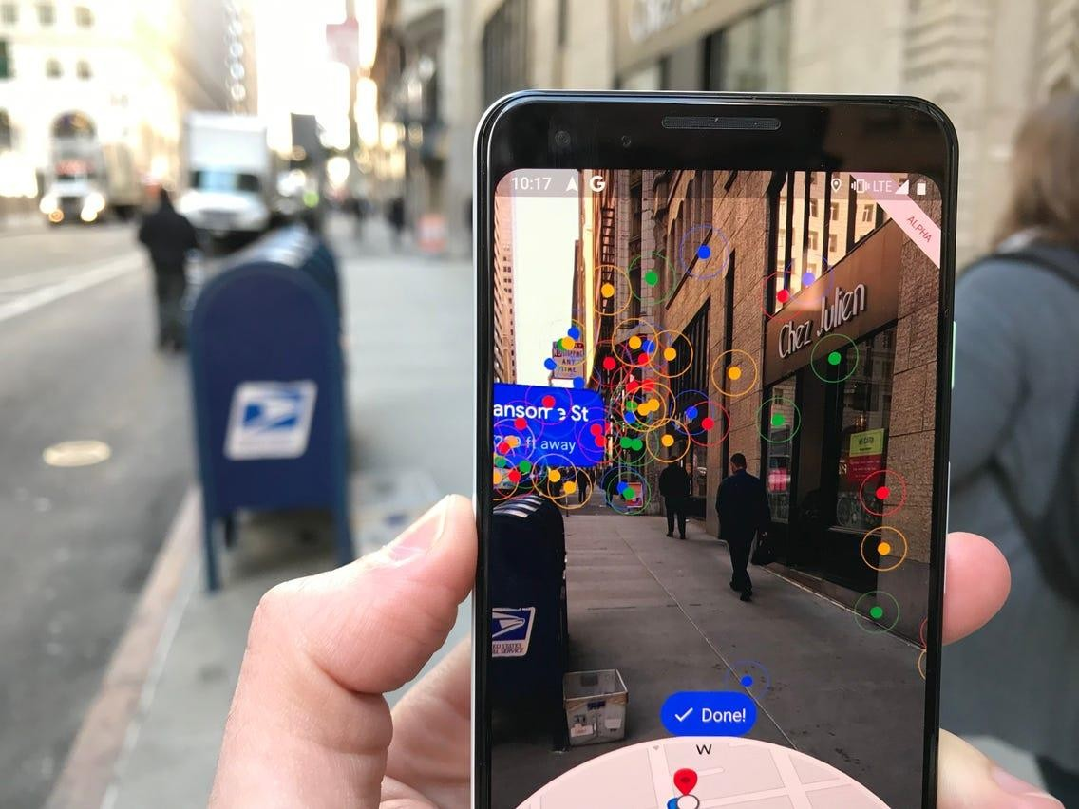

**Figure 1.3: Augmented Reality Map**

### Motivation of the Study

The core to our motivation was to contribute on the sector of Augmented Reality (AR) which has a significant impact on the technological market. The idea of this study came to us by observing the economic growth rate of tourism sector. As our country has many tourist spots, so a huge number of tourists come to visit the attractive places of our country every year. But they find it difficult to navigate an unknown place. The information from the manual map is not sufficient to visit any place. To make it more informative and attractive, we are implementing AR based 3D Map in our handheld devices which are helpful for those tourists. These real life situations gave us the ideas and motivation to integrate the 3D map which will create an efficient mobile AR system and will pave the way for future work on the field of AR.

### Problem Statement

As we find something such as historical place, specific road or any significant object from a well designed soft copy or printed copy map, sometimes it is difficult to interpret from the image and also it can be uninformative. So, the problem is encountered of how to extract relevant correct information from an image as the investigator may not feel that much of interest and may not find that much of content unless the identification of the position. In that case a 3D map can completely change the seeker’s mind via its Augmented Reality representation which provides more information about an unknown place by showing short video about that place so that the person who is going to find something can get more influence and courage to find the actuality in details.

There is a need for study to come up with a solution to integrate Augmented Reality technology into the map where the user’s can see 3D, 2D view of Bangladesh by using smart devices (mobile phone, tablet and smart watch). It allows the 3D map to become a dynamic source of information. The evolution of AR setups has moved towards handhelds and mobile phones significantly (Wagner, 2007).

### Research Objective

General Objectives-

In this study, we are proposing to develop a framework for Augmented based system for Bangladesh map.

Specific Objectives-

* + - To design an Augmented Reality framework for Bangladesh map
    - To develop an Augmented Reality based system on the proposed framework using Vuforia library and Unity Game Engine for Smartphone’s
    - To implement a virtual 3D model into the proposed system
    - To evaluate the system to find out the effectiveness of AR as a system for Bangladesh map to expand our tourism
    - To conduct a survey among AIUB students to find out the correctness of the proposed system

### Contribution of the Study

Huge amount of tourists visit the tourist spot of our country every year to observe the beauty of nature. Our handheld augmented reality based map will help the tourists to get a visual overview of some attractive tourist places. This system will be an interactive way for the tourists to retrieve information for the map. We are going to build up a system by applying augmented reality technology in Bangladesh map. This is difficult to find out similar types of work mainly in Bangladesh Map in AR from the previous published journals. So, this is the first time we are applying augmented reality in Bangladesh map. We are virtually representing in Bangladesh map by using mobile device. This augmented reality system will contribute to economical development of our Bangladesh tourism sector.

### Summary

For this study, we have proposed a mobile augmented reality system by which tourist can easily use a map while visiting our country. The objective of this study is to develop an Augmented Reality based system on the proposed framework using Vuforia library and Unity Game Engine for Smartphone’s. The key contribution of this study is to implement a virtual model such as 3D model, audio-visuals and multimedia generation into the proposed system.

### Overview

# Chapter-2 Literature Review

This chapter covers the literature review which focuses on the mobile AR technology and the previous researches conducted in Augmented Reality application. The first part refers to the definition, past researches and the advancement history of Augmented Reality. The second part explores the tracking and image processing technique, Augmented Reality SDK (Software Development Kit) and evaluates the overview of Vuforia tracking library and AR toolkit. The third part is a review of graphics and multimedia generation on 2D, 3D object interaction of Augmented Reality technology. The fourth part reviews of augmented reality related work that was conducted before.

### Augmented Reality

Augmented reality is a new technology and AR is on the verge of becoming a part of life. The perception of the user, better acknowledgement about the surroundings and the interaction with the surroundings can be improved by Augmented Reality (Iftene & Trandabat, 2018). For the advancement of emerging technological fields, usable AR applications such as authoring tools, tracking mechanism, display systems and input devices can be created to solve many technological issues (Billinghurst, 2002). For creating augmented reality applications what needs to be focused on is the user centered design. Augmented Reality permits the user to observe the actual world with virtual surroundings overlaid on it (Azuma, 1997). AR can simplify the user’s life by introducing virtual information from the actual world (Carmigniani & Furhut, 2011). AR technology has the following three characteristics-

* + - Combination of Real & Virtual environment
    - Interactive in real-time
    - Registered in 3D (Azuma, 1997)

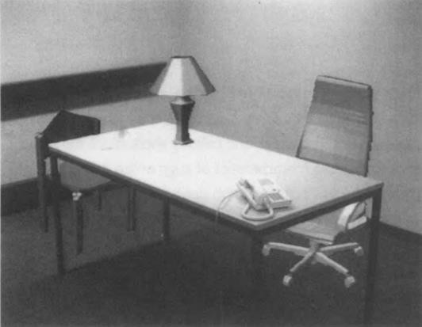

#### Figure 2.1: Real desk with virtual lamp & two virtual chairs

Computer vision is the advancement of augmentation that happens in actual time which determines that users are conscious of being in the actual world (Azuma, 1997). To solve the difficulties arises from the real world or complex conceptual visualization can be eliminated by affordance that helps students to locate an unknown location easily (Nincareana et al., 2013). Now-a-days, the combination of AR with the surgical navigation system aims to improve the safety and reliability of surgery by implementing an optical see-through HMD (Head-Mounted Display) (Chen et al., 2015).

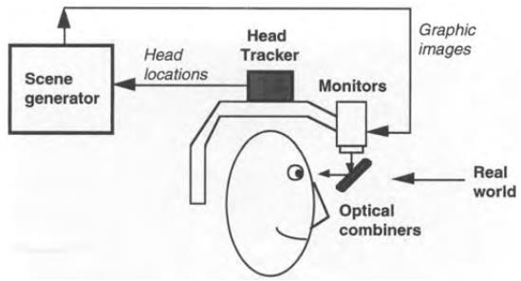

#### Figure 2.2: Optical see-through HMD conceptual diagram

Over the last decade, the evaluation of mobile augmented reality has progressed rapidly between 1968 and 2014 (Arth et al., 2015). The primary occurrence of mobile AR can certainly be related with the improvement of the wearable AR, in a sense of experiencing AR during locomotion (Arth et al., 2015). Mobile Augmented Reality is perhaps the most unstable development region for AR applications right now (Criag, 2013). Augmented reality utilizes different types of technologies like geolocation, simultaneous localization, and image processing & tracking among many others. These types of technologies manipulate the virtual objects to overlay the physical objects.

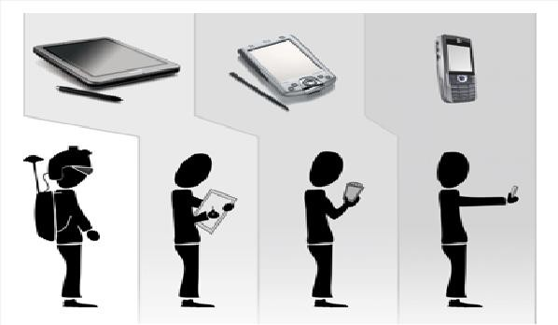

#### Figure 2.3: The Evaluation of Mobile AR

The following technologies of augmented reality are-

1. SLAM
2. Depth tracking
3. Image processing and projection

#### SLAM (Simultaneous Localization and Mapping):

The navigation problem of an unknown new environment can be communicated by SLAM. We can represent SLAM by panoramic mapping, sensor fusion and place recognition (Reitmayr et al., 2010). Localizing sensors of a gyroscope or an accelerometer can be worked as SLAM to

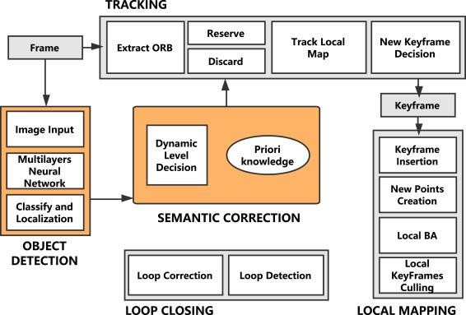

perform simulation. The benchmark framework enables the user to compare the SLAM approaches for analyzing the results and for measuring the errors (Burgard et al., 2009). This simulation task is used to portray the objects. As we can’t get accurate outputs all time by using GPS, but precision within a few inches should be required to move about safely (Thrun & Montemerlo, 2006). Robots enhance their own maps as they go by using SLAM. It lets them know their position by the alignment of sensor data which can be collected to build out a map for navigation. By completing image mapping, SLAM allows AR image simulation which projects the image in the correct dimension. The SLAM community has constructed amazing development over the last 30 years which enable large-scale real world applications by witnessing a slow transition of this emerging technology (Cadena et al., 2016).

**Figure 2.4: Flow chart of Simultaneous Localization and Mapping Depth Tracking:**

Depth tracking is the measurement of the tracking objects from the camera sensor (Taskinen et al., 2015). This tracking process is used to control the size and dimensions of the virtual objects (Taskinen et al., 2015). To achieve more robust tracking, the combination of some method needs to be performed as the depth sensor can’t work properly under the sunlight conditions (Valentin

et al., 2018). Depth sensors can extract features from camera image to gain actual model of objects that can be detected by color cameras. The depth image of the scene can be acquired to capture the objects by depth camera and based on the depth image, the segmentation and dynamic tracking of objects can also be implemented to enable immersive and realistic user experiences (Yang et al., 2017). At the time of taking pictures in a camera, it mainly focuses on the camera picture to locate it in a specific distance and the pictures can be blurred for the rest of the background (Du et al., 2020). Depth tracking enables user to measure the distance of the object accurately that is captured from the camera and the blurred background is also ignored (Du et al., 2020).

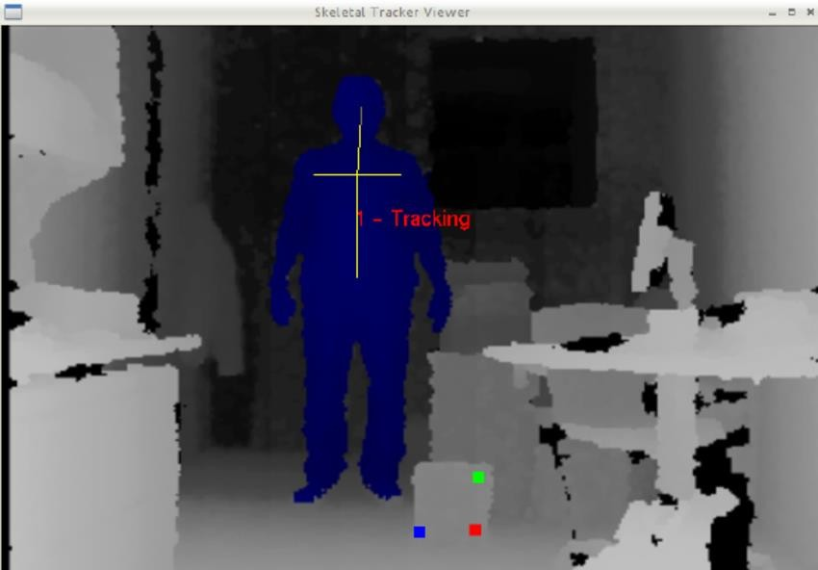

**Figure 2.5: Depth Tracking**

**Image Processing & Projection:**

Image processing and projection is the last stage of the AR simulation. In image processing, text recognition (preprocessing, segmentation, feature extraction and classification), marker recognition and markerless recognition can be implemented to generate output from the source ([Babaei](https://www.researchgate.net/profile/Hossein-Babaei) et al., 2012). Image processing technology can be followed by importing image via an electronic device (Desktop, Mobile Phone), by analyzing and manipulating image for the enhancement of an image (Stork et al., 2002). Projection based augmented reality is a method of providing digital information (text, images, animations, videos) to user’s within a static context (Stork et al., 2002). It requires one or more optical devices to track objects. It can reduce the

need for computer monitor, user’s cognitive load, integrate into manual workflows and provide feedback on completed tasks for process improvement (Stork et al., 2002).

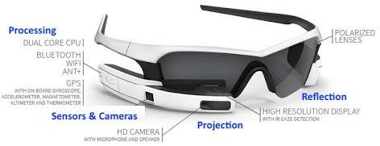

**Figure 2.6: Image Processing and Projection**

### Tracking and Image processing

The image processing method targets to expand the image which can be simply describable (Polycarpo & Watt, 1998). This method includes the following steps such as, importing the image via image acquisition tools, analyzing and manipulating the image. Object tracking in AR is advancement for image processing applications like object recognition, navigating systems and observation systems (Vuforia, 2021).

### Augmented Reality SDK Framework

An Augmented Reality SDK (Software development kit) is the basic technological software engine that powers the development and design of new Augmented Reality apps and experiences (IoT Zone, 2019). The Augmented Reality SDK behind for many components of the applications, which are currently available, including content rendering, AR tracking, and scene recognition (IoT Zone, 2019). Content rendering relates to the digital information and 3D objects that can be overlaid on top of the real world, tracking represent the eyes of the application, and the scene recognition element acts as the central system of the application (IoT Zone, 2019).

#### Overview of Vuforia as Tracking Library

Vuforia Engine is a Software development tools (SDK) for creating Augmented Reality apps for mobile devices launched by Qualcomm (Vuforia, 2021). Computer vision technology can be utilized to perceive the objects in actual time by modifying the objects position (IoT Zone,

2019). The Vuforia Engine is simply added to any project. The advantage of adding this function of virtual button is to detect the target image according to the scheme (IoT Zone, 2019). Advance computer vision functionality can be simply included to Android, iOS, UWP apps and Unity editor, to generate Augmented Reality experience that connects with objects and the Environment (Vuforia, 2021). The main functionalities of Vuforia include the recognition process of visual objects, texts and environments recognition, VuMark and Vuforia object scanner which task is to allow scanning and creating object targets (Sciforce, 2019). Vuforia provides Application Programming Language (API) in C++, Java and the .NET languages through an addition to the Unity game engine (IoT Zone, 2019). Vuforia SDK is much easier to use than the other toolkits which only offer a single platform (IoT Zone, 2019)

#### Figure 2.7: Vuforia AR SDK

|  |
| --- |
| **LIBRARY-**Vuforia |
| **IMAGE PROCESSING-**Template matching |
| **REGISTRATION-**AR registration between the real world and 3D world |

**Table 1: Vuforia Tracking**

#### Overview of ARToolkit+ as Tracking Library

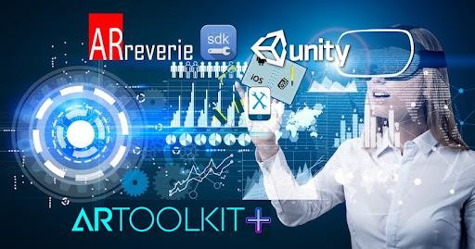ARToolkit+ is one of the finest open sources tracking library for augmented reality tools for app development and easy to use alternative to Vuforia which supports 3D object recognition, environment perception and cloud recognition (WBPRO, 2019). The tracking functionality is required to build augmented reality applications in ARToolkit+ that provides computer vision library (Sciforce, 2019). With iOS11, introduces its own AR kit by the announcement during worldwide developer’s conference in June, 2017. It supports both single and dual cameras (WBPRO, 2019). The supported platforms of ARToolkit+ are android, iOS, Linux, Windows, MAC OS and Smart glasses (Sciforce, 2019). In addition to this, it also supports through which developers can simply create location based Augmented Reality apps (WBPRO, 2019).

#### Figure 2.8: ARToolKit+ AR SDK

#### Overview of ARkit as Tracking Library

ARkit keeps 2-dimentional image detection and tracking which means the potentiality to immerse objects into AR experiences (Sciforce, 2019). Developing apps can be permitted to recognize spaces and 3D objects as well as virtual objects on surface (Sciforce, 2019). Unity worked to ensure the latest features from iOS11 and ARkit were supported, setting developers up for greater success (Sciforce, 2019).



**Figure 2.9: ARkit AR SDK**

### Graphics and Multimedia Generation

Augmented Reality (AR) has gained popularity of being a useful visualization tool for coming up with and operations style in building, producing, and alternative process-oriented engineering domains. Multimedia implies that PC data can be figured out through sound, video and movement (Multimedia, 2021). One of the major challenges in creating AR visualizations is to project graphical 3D objects onto a user’s view of the real world and create a sustained illusion for the virtual and real objects.

#### Overview of Unity as 2D/3D graphics

Unity is a cross-platform integrated game engine with a built-in IDE developed by Unity Technologies Co.Ltd (Riccitielo, 2014). Unity is equally suited to making each 2D and 3D games. It permits Vuforia SDK extension modules to distinguish and makes AR applications and games. 3D games typically utilize three-dimensional geometry, with materials and textures delivered to the outside of GameObjects to make them appear as strong environments, characters and objects that make up user’s game world (Unity, 2021). Several 2D games use flat graphic, generally known as sprites that do not have any three-dimensional geometry at all (Unity- Multiplatform, 2021). Additionally it offers to release the application in the desired platforms, such as Windows, iOS and Android. 2D image can be converted into 3D by providing the

maximal visualization of objects through Augmented Reality (AR) (Unity-Manual, 2021). Based on the Vuforia platform, augmented reality markers were made to utilize the AR innovation.

#### Figure 2.10: Unity as 2D/3D Graphics

#### Overview of OpenGL

OpenGL (Open Graphics Library) is a cross-language; cross-stage Application Programming Interface (API) for delivering 2D and 3D vector designs (OpenGL, 2021). Silicon Designs, Inc. (SGI) started creating OpenGL in 1991 and started to use this in various fields like augmented reality, logical representation, data perception, energy entertainment, manufacturing, flight simulation, and computer games (OpenGL, 2021). Despite the fact that it is feasible for the Programming interface (API) to be carried out completely in programming, it is intended to be executed for the most part or altogether in equipment (OpenGL, 2021). The earliest forms of OpenGL were developed with a partner library called the OpenGL Utility Library (GLU). The GLU particular was last upgradated in 1998 and relies upon OpenGL highlights which are currently deprecated (OpenGL, 2021).



**Figure 2.11: OpenGL**

### Basic Applications of Unity 3D & Vuforia in AR

AR is the latest technology developing from virtual reality (Azuma, 1997). This technology improves the user's perception of the actual world that overlays the computer-generated virtual objects and eventualities (Billinghurst, 2002). Vuforia AR Software Development Kit (Vuforia AR SDK) is intended by Qualcomm for AR applications of mobile devices (Vuforia, 2021). 3D objects or planer images can be identified by computer vision technology. It also let the developer to place the virtual objects properly that can be adjusted in front of the lens through camera viewfinder. New technologies, 3D modeling, device localization, multimedia, session management, real-time video display, tracking are the common features developed by AR. It consists of the various combination of geometric model located in virtual world, establishment of physical model and the generation of behavior model. This part is mainly finished by Unity 3D (Unity, 2021). The virtual object is added to reality and therefore the human-computer interaction is realized. This step is especially achieved by Vuforia SDK.



### Related Work:

#### Figure 2.12: Unity 3D and Vuforia in AR

Bernelind (2015) described an AR experiment that can examine the navigation process by using Augmented Reality from a usability perspective in compared to a standardized map. In this study, AR system was implemented to develop a manual map like Google Maps which is widely used on a smart phone. The data of initial survey was conducted by getting feedback from the users of the previous experiences using the electronic tools that were used during survey. 10 test subjects were chosen to create a prototype for the AR framework to reduce the threat of fatigue and recognition while performing the group design. Data collection process was designed in terms of efficiency, learnability and satisfaction for collecting both qualitive and quantitive data. The prototype was implemented by using few guidelines to designated destination to replicate the AR view. The post-experiment questionnaire was conducted by using Likert Scale to get a good qualitive and quantitive data. The results indicated that majority of the participants (70%) had used an application with Augmented Reality before, 30% had used smart phones to navigate a new place which can save their time and help them to keep track of the destination address. The author also provided some discussion on how AR prototype can be developed for navigational purposes and the method’s possible impact on the results.

Larsson (2018) described of how Augmented Reality can be used to locate the nearby city services using visualization of geographical data that influenced the user’s perception of the depth of the virtual object. The study looked at the user’s interaction with the AR prototype using a think-aloud approach. Specifically, the experiment demonstrated a quantitive study which showed the valuable insights on how users can experience AR through the interaction with a live AR prototype. The authors collected data through a Google form by using social media groups such as Facebook and over email. The outline of the study was to design an AR-prototype based on information content, usability, functionality, performance and interaction. The study ended with a semi-structured interview to gather in-depth knowledge about how users can interact with Augmented Reality to find nearby objects. The participants had used a smart phone before and were chosen to create variety for the study based on gender, age and occupation. The results confirmed that it was negative based on prototype performance but positive towards a functional product which is more realistic factor to the navigation. This study also reported that AR glasses can eliminate unexpected problem to provide an error free results from a technical perspective for location-based applications.

Werner (2018) found that Augmented Reality can provide intermediate tool between the human and information system through visualization using maps. Challenges of mobile augmented reality were discussed in this article. The author figured out that image capturing lightning conditions, energy consumption, large amount of data, accuracy of sensor information, new methods of interactivity and realism and security problem are the most common challenges faced by handheld devices. The author also demonstrated that AR technology can be used as intelligent map creation for the advancement of digital map, GIS and WebGIS.

Jenny et al., (2019) demonstrated a detailed user-based study to examine 3D AR map with Unity game engine. Interaction with AR and VR maps were used to analyze and to visualize of geospatial data through gestures and handheld controllers. This study represented the results of recent research projects which were explored to measure the body gestures by controlling with the help of AR and VR technology for gesture-controlled interaction. The authors used motion- tracking controller to capture, interpret and compare various gestures. The authors also discussed interaction with exocentric globes, egocentric globes, and flat maps for handheld controllers in VR.

Bobrich & Otto (2002) illustrated the cartographic visualizations which were determined by pattern-recognition technique on the border of the map by inserting unambiguous tags. Artificial virtual objects were determined by the parameters which can be captured by a small video camera for overlaying and combining purposes of video stream. The authors calculated data by performing same data analysis and combining the real and virtual objects. The study showed that user can interact with the map by activating new layers to visualize the geographical analogue map. The authors examined the possible operations with manual map, the new optimization of handheld devices, and integration in AR map. The study had a clear discussion on a mobile collaborative AR-system that can be tracked by an inertial tracking device and pattern recognition. ARToolkit was used to determine the orientation of matrix to set the position of virtual display and OpenGL API was used to draw virtual objects that can be easily recognized and executed.

McMahan et al., (2015) examined the effects of navigation tool using Augmented Reality technology for students with disabilities. AR navigation tool was used to navigate unknown places for employment opportunities that may help to grow up the individual’s ability in decision making skills. The experiment was designed to demonstrate the functional control by providing navigation aid treatment. Data collection process was evaluated by collecting navigation checks, correct responses and assisted responses. Results indicated that disable students can travel a location more successfully using Augmented Reality map. The authors provided some discussion on the effectiveness of three navigation tool while exploring to an unknown place within their ability to navigate independently.

### Summary

The literature review conducted for this study includes previous research on Augmented Reality. In this chapter, the overview part; image processing, Augmented Reality Framework, overview of Vuforia, ARToolkit+, ARKit, Unity, OpenGL and basic applications of Unity 3D and Vuforia in AR is discussed briefly. Additionally, numerous related work on Augmented Reality which was conducted before is also discussed and reviewed here.

### Overview

**Chapter-3 Research Methodology**

This chapter explains the research methodology and framework with respect to the research objectives presented in chapter one. Additionally, this chapter also describes the explanation of the system development methodology of the mobile AR system.

### Research Methodology

The main purpose of this study is to develop 3D virtual object and multimedia generation and implement them in Vuforia library. Additionally, the objective of this research is to integrate all these modules in the “Applying Augmented Reality in Bangladesh Map” system. Therefore, our purpose is also to evaluate the effectiveness and efficiency of these modules in the Bangladesh Map based on user’s feedback.

#### Framework

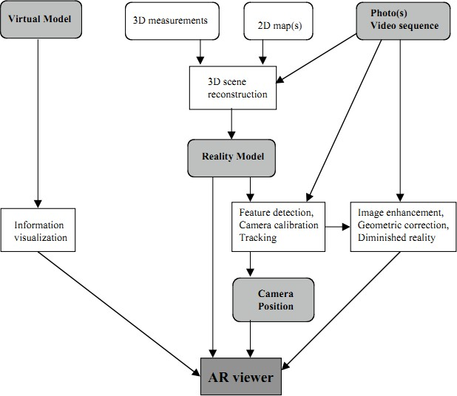

**Figure 3.1: Conceptual Framework of an AR System**

Klinker et al., (2001) described the conceptual framework for augmenting images of the real world with virtual objects. In virtual model, information visualization tasks can be integrated by OpenGL which can show video output in AR viewer. 3D scene or 2D map can detect features, track camera calibration in reality model through image enhancement, geometric correction and diminished reality that can be viewed in AR viewer (Klinker et al., 2001).

The flowchart of the system is outlined below-

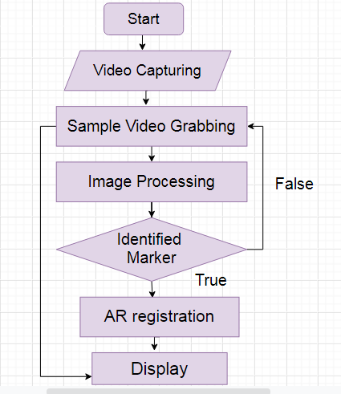

#### Figure 3.2: Flowchart of the System

When the user’s start the system, the camera of the Smartphone will automatically open and start video capturing. So, if the users hold the Smartphone’s camera on the map of Bangladesh, it

will start the scanning process by feature model matching. When the required map matches with the feature model map of Bangladesh division, it will start grabbing a video sample; it will process the target image and will try to identify the marker. By completing the synthesis of video frames, if it exists in the database of the system, then the 3D virtual model of the divisions of Bangladesh Map will be showed in the marker area. Otherwise, it will return to video grabbing.

### System Development Methodology

The graphical representation of a software life cycle defines with the term of SDLC (javaTpoint, 2021). The SDLC could be a procedure to form a high-quality product that meets requirements, reaches completion among times and prices estimates (tutorialspoint, 2021). Without the execution of a proper life cycle model, the development of a system would not be a success (javaTpoint, 2021). In this study, we have chosen SDLC (System Development Life Cycle). The minimization of risk and the highest quality of the product is ensured by SDLC (Rather and Bhatnagar, 2015). The SDLC defines the framework that includes different activities and tasks to be carried out during the software development process (Rather & Bhatnagar, 2015). SDLC is a methodology for designing, building and maintaining information and industrial system. Using the SDLC phases the user can develop the software according to their requirement (Navita, 2017).

We have chosen SDLC because it is the best suited model for small project in compared to other software development model (Amlani, 2012). Many researches have been conducted before by using SDLC because the researchers got satisfactory result from this model. Amlani (2012) found that this process facilitates to better cope with the organizations need and the early detection of errors. Since the following phases are dependent on various phases, this approach ensures the perfection of the stage before delivering to next stage (Amlani, 2012). This approach creates considerable system documentation. The implementation of this model is easy and user friendly. Testing is inherent to every phase and it is less costly (Navita, 2017). Client can get feedback from users and this is much better model of software process. It has reuse capabilities and better productivity when new prototype is obtained every time (Rather & Bhatnagar, 2015). There are five stages in the development methodology-

1. Planning
2. Requirement Gathering & Analysis
3. Development & Implementation
4. Testing
5. Deployment

SDLC in this research is shown as follows-

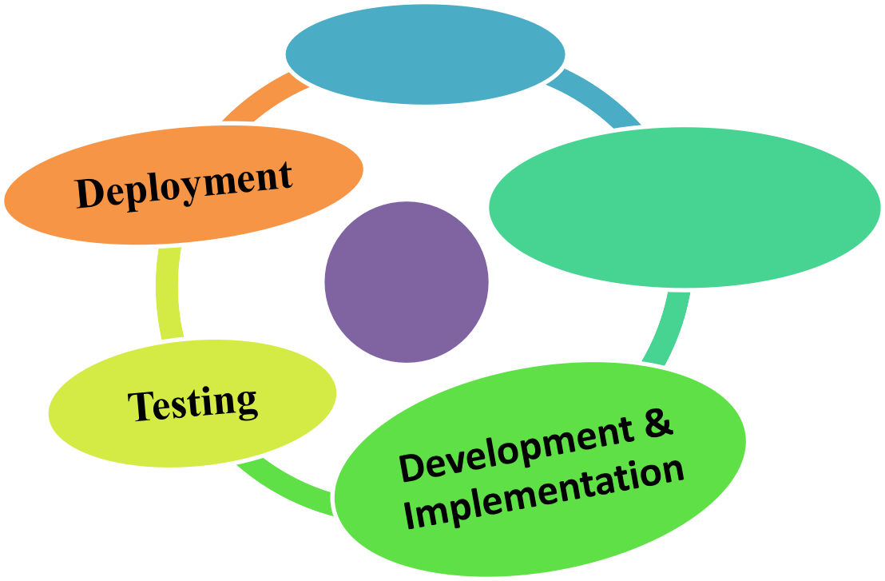

**Planning**

SDLC

**Requirement Gathering & Analysis**

#### Figure 3.3: System Development Life Cycle (SynepseIndia, 2019)

1. **Planning:**

Without a perfect plan, the development of any system is meaningless. This is the most essential aspect of the SDLC. The planning phase involves resource allocation, capacity planning, project scheduling and cost estimation (Shylesh, 2017). Before implementing the system, a clearly defined purpose and scope of software system should be focused to create the software successfully (Shylesh, 2017). Planning for the standard assurance necessities and identification of the risks related to the project is additionally drained the design stage. A group discussion will help to plan and identify the requirements properly. The work will be distributed to the group members.

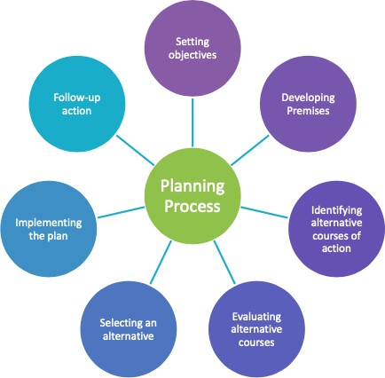

#### Figure 3.4: Planning

1. **Requirement Gathering & Analysis:**

The requirement gathering & analysis for the project are the most important part of the SDLC. There are some process for requirement gathering & analysis: capture initial requirements, enhance requirements, interface analysis for software, prepare requirement specification, review documents and prototypes and modify the documents based on the requirements (Shylesh, 2017). At this phase, the resources will be gathered and analyzed. Primary data will be collected for the map from Bangladesh Map through android Smartphone’s. Secondary data will be collected from online resources. Android is considered as the platform for the implementation of handheld AR technology. Unity game engine and Vuforia SDK is used for this study.

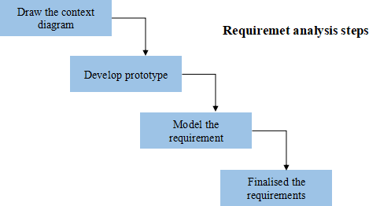

#### Figure 3.5: Requirement Gathering & Analysis

1. **Development & Implementation**

In this phase, actual development of the project starts according to the designed architecture. If designing is done successfully then this phase is not much difficult. The collected resources will be manipulated later based on the requirements of the system. For mobile Augmented Reality, the first task is collecting a real-time image. A Smartphone camera is used to capture a real-time image which can be tracked easily. Various high level programming languages can be used for coding, such as C, C++, Java and PHP. The programming language is chosen according to the type of software being developed. Vuforia SDK will be installed from Vuforia developer portal and can be accessed through the Unity Package Manager by adding Vuforia's package repository.

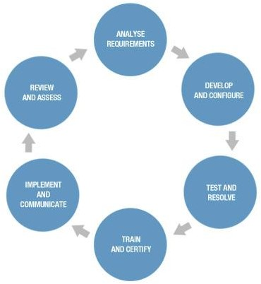

#### Figure 3.6: Development & Implementation

1. **Testing**

Product defects are reported, analyzed and corrected in this phase until the product meets the quality standard. Debugging has to continue to correct the bugs and issues that will be found in the product.

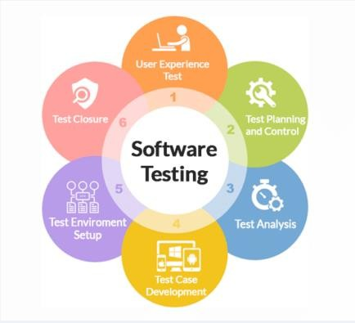

#### Figure 3.7: Testing

1. **Deployment**

After successful testing and correction of the system, the system will be declared ready to use with the Bangladesh Map.

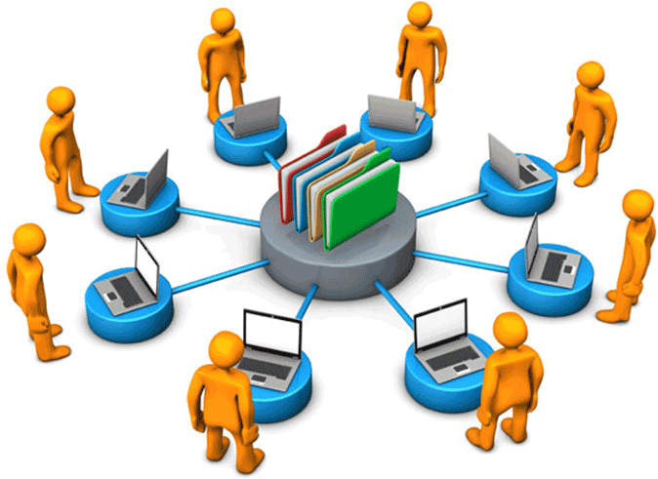

**Figure 3.8: Deployment**

### Work Planning & Execution

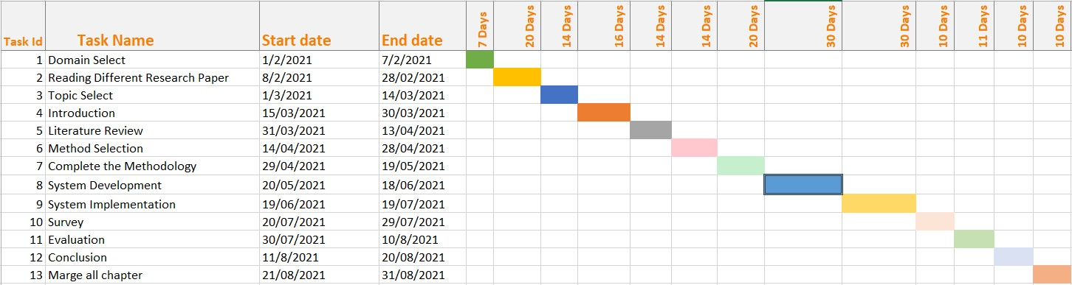

### Budget

**Figure 3.9: Gantt chart**

|  |  |
| --- | --- |
| **Equipment** | **Price(taka)** |
| Computer | 50,000 |
| Accessories | 500 |
| Map | 200 |
| Smart Phone | 20,000 |
| **Total Price** | **70,700** |

### Summary

In this chapter, the System Development Life Cycle is discussed for development methodology. The overview of framework architecture is also reviewed here for a mobile AR system. The five stages of development methodology: Planning, Requirement gathering & analysis, Development & implementation, Testing & Deployment is analyzed in this chapter briefly for implementing the system software. For controlling the interaction and some specific functionality, we have used default tracking scripting code of Unity.

### Overview

**Chapter-4 Implementation & Evaluation**

This chapter discusses the implementation and evaluation on the development of augmented reality based Bangladesh map and the implementation of graphics audio video modules of the interactive media for all department students. Not only in the science department but also different category students can use this mobile-based AR system for Android Smartphones. For capturing real-time video, the camera API of Android is used. Furthermore, this chapter explores the findings to determine the usefulness and user satisfaction of graphics and video –visual modules of augmented reality technology in Bangladesh map.

### Framework

The architecture of the system is outlined below-

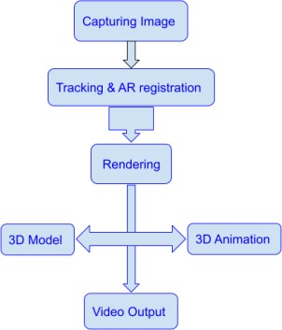

**Figure 4.1: Flow chart of Architecture of the system**

### System flow

System flow is the process by which the internal procedure of any system can easily describe. The flowchart of the system is outline below-

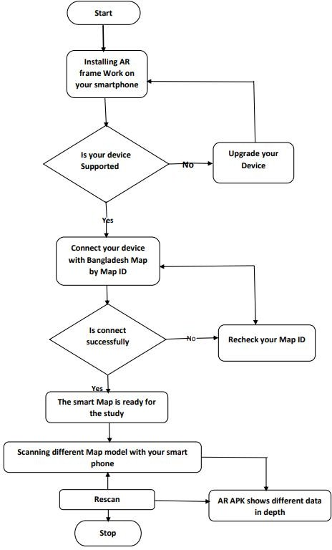

**Figure 4.2: System Flow of Augmented Reality based Bangladesh’s Map**

### Implementation

#### Vuforia Tracking Library

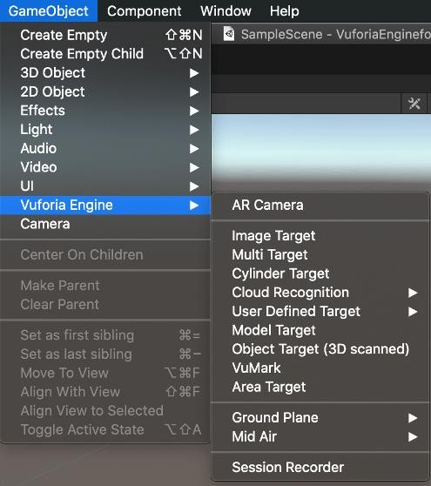Now-a-days, Vuforia Engine is one of the most widely utilized platforms for AR development, with support for leading phones, tablets, and eyewear (Vuforia, 2021). Vuforia Engine is a software development kit (SDK) for implementing Augmented Reality apps (Vuforia, 2021). We have used Vuforia as tracking library to develop our augmented reality system. Advanced computer vision functionality permits the developer to identify the objects from the actual world (Vuforia, 2021). The main functionalities of Vuforia is to include the recognition process of visual objects, texts and environments recognition, VuMark and Vuforia object scanner which allows scanning and creating object targets. It has the volume to recognize objects that are in 3D as well as 2D. Vuforia Engine also offers a variety of trackable targets and capabilities that can be categorized as Images, Objects, and Environments (Vuforia, 2021).

#### Figure 4.3: Vuforia Tracking Library

#### Video Capture

In this research, an android smart phone’s built-in Android camera API is used to integrate the Vuforia tracking library for capturing the video. For AR operations, the real-time image was captured by a Smartphone camera and Video was captured at 1080x1920 resolutions. The default script given by unity was used for opening the camera and video capture option. We have also modified a little bit in the rendering part, which is given below-

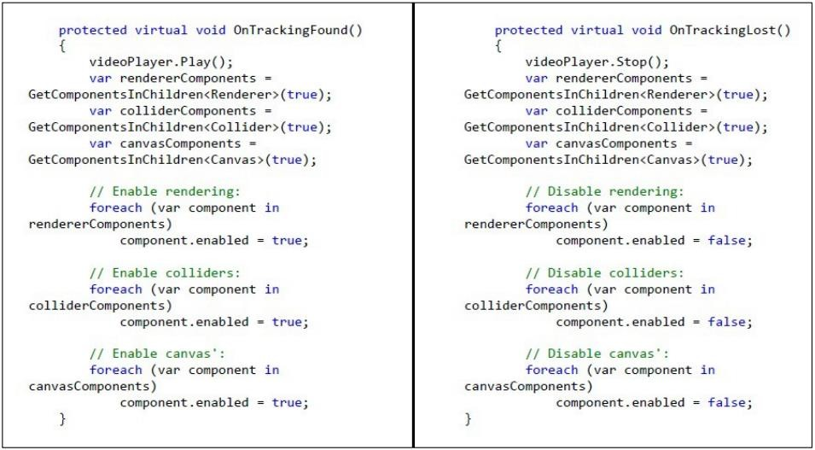

#### Figure 4.4 Snapshot of the script of video capture for Android Device

After starting the application, the smart phone camera automatically turned on. The camera was scanning for registered markers to show 3D videos of the required image. It showed the desired video or 3D shape into our android devices after finding the appropriate marker. We had called “videoPlayer.Play()” function into the class “OnTrackingFound()”. It enabled rendering when it found the appropriate marker. When the target image (marker) was lost the video or 3D shape would also disappear. We had also called “videoPlayer.Stop()” function into the class “OnTrackingLost() and it stopped the rendering process.

#### Tracking

Normally, real-time marker detection is performed by Augmented Reality. Complex calculation of AR registration of the real-time video stream and the 3D world is also needed in Augmented Reality. Vuforia’s built-in tracking and AR registration systems are used in this research.

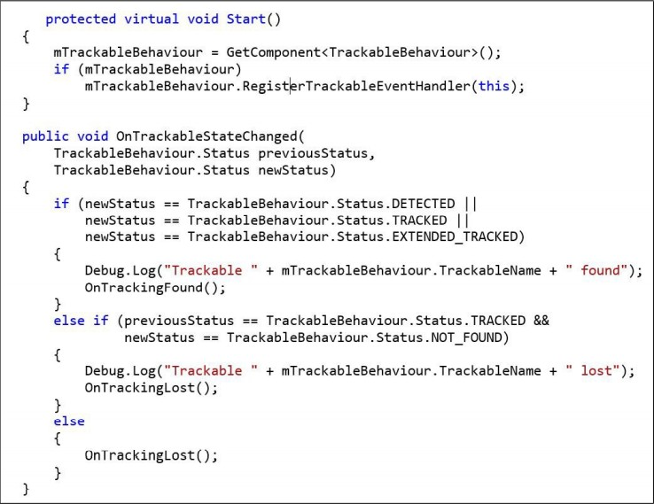

#### Figure 4.5: Snapshot of the script of Tracking

At first, the target image which was uploaded in the database tried to match the image with the marker. If any matches found, the function “OnTrackingFound()” was called and when the target image lost from the detector, the function "OnTrackingLost()" was called. If the tracker did not find any match it also called "OnTrackingLost()" function.

#### 2D and 3D Integration

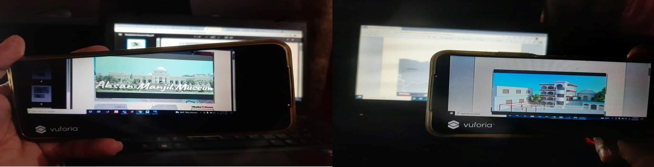

**Figure 4.6: Sample pictures of 2D and 3D video capturing**

At first, we have uploaded the target images in Vuforia database and the target images must be augmented by few stars. The 3D video of different division was configured with Unity and CodeBlocks. Users can see the 3D view of different division by holding the camera on a specific division’s image of Bangladesh map. We have captured some images by an android phone camera from the video. When the AR application recognized the marker by scanning the target image, it displayed the specific video on the mobile screen with audio. We have also added some audio to the specific division’s video by taking it from different online sources. The video would also disappear and scan for marker again when target image was vanished.

### Evaluation

We will implement the user evaluation part by conducting a survey. The main target of this study is to know that how much the mobile AR system is effective in Bangladesh Map. To find out the effectiveness, 55 participants will participate in the survey by providing their feedback after using our system.

#### Participants

The evaluation represents the graphical expression of the data which was evaluated among almost 55 participants in numerous professions to know the efficiency of augmented reality map. 85% of participants were selected from fresh undergraduate in discipline institution and rest of them was service holder, contributors also provided efficient and precise judgment. Most of the participants did not familiar with the mobile AR technology.

#### Finding the Effectiveness

In this research, a questionnaire was used as a method for collecting data to get the results for users. All respondents were anonymous when research material was collected, stored and

published. This survey was created in online by making a Google form and stored on a secure Google Drive account for data collection and analysis. Online (web URL) version was distributed to the users for data collection. By using pie-chart, data findings tasks were done which was used in analysis plans and to examine results in this study. Each of the questions used in the questionnaire contains a data reduction technique (percentage analysis).

We have conducted and analyzed two questions to find out the effectiveness for evaluation part. Help from individuals and social networking platforms (Facebook, WhatsApp) were taken to reach the students. Students were cordially requested to circulate the survey (web-link) to their course mates, friends, senior and junior. The evaluated interrogatories are provided with the graphical expression of participant’s decision in below.

* + - 1. Did you ever use the Augmented Reality technology before?

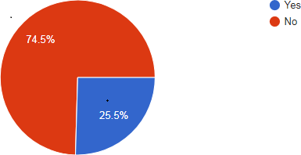

#### Figure 4.7: Pie-Chart-1

The above pie chart shows that 25.5% participants have used augmented reality technology before & the rest of the 74.5% participants didn’t ever use the technology before which is a surprising fact.

* + - 1. The Augmented Reality technology has the effectiveness to expand the tourism sector in Bangladesh.

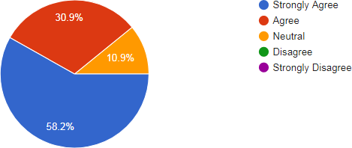

#### Figure 4.8: Pie-Chart-2

In this expression, most of the participants (89.1%) are acknowledged with the fact that augmented reality technology can be effective to expand the tourism sector in Bangladesh which is quite satisfactory and 10.9% contributors are neutral in their decision may be they are confused about their opinion.

### Findings

In this research, 55 participants were participated in the survey by providing their valuable opinions. The survey was targeted to the participants who have minimal education with computer literacy as the objective of this study is to find out the effectiveness of Augmented Reality map. Among them, 38 participants are male and 12 participants are female and their age range was from 22 to 28. A total of 2 questionnaires (online versions) were collected and analyzed to find out results.. From the survey results, it can be clearly concluded that 89.1% participants strongly agreed to the fact that the augmented reality technology can be effective to expand the tourism sector in Bangladesh and 10.9% gave a neutral response. The significance of this Augmented Reality map is that it can captivate the tourists by enhancing the attractiveness of a map using Handheld Augmented Reality. It allows the 3D map to become a dynamic source of information. This augmented reality map also helps to boost up our tourism sector which can contribute a significance change in our economical development. Thus, this AR map is effective in terms of user satisfaction. Our system will easily identify which place is better to go easily. Basically this system will be created for foreigner tourist people because they do not know about the tourist

spots in our country. Tourist spots can be easily found through Augmented Reality maps. Representation of our country in front of other nations will be easier.

### Summary

This chapter mainly discusses on the implementation and the user evaluation that was conducted to evaluate the effectiveness of the systems of 3D and multimedia modules. Augmented Reality based Bangladesh map is developed using the mobile AR system. Most of the participants have reviewed the system to be effective to expand the tourism sector in Bangladesh. The findings of the participant’s satisfaction indicate that the implementation of the multimedia and 3D module is successfully implemented into the mobile AR system.

### Overview

# Chapter-5 Conclusion

The outline and conclusion of this study is represented here. The methodology, study objective, significance and limitations of the study are also documented here. Additionally, this chapter also inserts recommendations for future analysis and study. The overall goal of this research was to structure a framework of Augmented Reality system for the tourists of our country by developing an interactive multimedia-based mobile AR application. Vuforia SDK and Unity game engine was used to integrate 3D and multimedia modules into the system for Android Smartphone. Along with that, a survey was conducted to experiment the efficiency of the system and to observe the user satisfaction. The result indicated the satisfactory outcome of the system which resulted that AR mobile system had been achieved.

### Summary of the Background study

Augmented reality is a new technology and AR is on the verge of becoming a part of life .The history of AR goes back to 1960s and both AR and VR were used as the first system (Johnson et al., 2010). Ivan Sutherland first created the augmented reality device called ‘The Sword of Damocles’ in 1968 (Billinghurst et al., 2014). Many professionals and analyzers have been evolving practical theories and application of AR into both academic and corporate settings during the last few decades. The main aim of AR is to enhance user’s visualization of the world that merges digital information by improving the ability to overlay virtual objects in the actual world.

### Summary of the Study Objective

In this study, we proposed a framework for an Augmented Reality based system for Bangladesh map and developed the system using Vuforia SDK and Unity Game Engine for Android Smartphone. The image tracking and detection was done by Vuforia. Unity Game Engine was used for rendering purposes. A survey was conducted to observe the correctness of the mobile AR system. The development procedure in this study was utilized by the Software Development Life Cycle (SDLC) to develop mobile AR system. The testing approach in this research used operational experience on the AR System and assessing their fulfillment and proficiency.

Overall, the mobile AR system satisfied the expected result of research objectives and could be additionally improved with a couple of new features.

### Summary of Methodology

In this study, the development methodology was SDLC (Software Development Life Cycle) because it is the best suited model for small project in compared to other software development model. Many research have been conducted before by using SDLC because the researchers got satisfactory result from this model. There are five stages of SDLC-planning, requirement gathering & analysis, development & implementation, testing and deployment. These stages were implemented for the development methodology of our system.

### Summary of the Implementation

The system was implemented by using Vuforia tracking library and Unity game engine. We had uploaded the target images in Vuforia database and the target images must be augmented by few stars. The 3D video of different division was designed with Unity and CodeBlocks. The proposed framework was based on rendering and image tracking for this study. The system would display the real-time video capture and 3D view of the eight divisions of Bangladesh Map. When the system started to capture the image from the map, the camera turned on automatically. After grabbing the sample, it scanned the image for registered markers and tried to match it. 3D output was displayed in the marker area after finding the appropriate marker. When the AR application recognized the marker by scanning the target image, it displayed the specific video on the mobile screen with audio. When the target image was lost and did not match with marker, it stopped the rendering process and again started video grabbing.

### Summary of Evaluation & Result

A survey was conducted and analyzed to evaluate the efficiency of the system and to observe users satisfaction. We made a team of 55 participants from the undergraduate discipline to get feedback from them for our mobile AR system. . This survey was created in online by making a Google form for data collection and analysis. It was stored on a secure Google Drive account for further evaluation. Online (web URL) version was distributed to the participants to give their feedback through the survey for data collection. Almost 89% respondents agreed that the system

was favorable to the users for getting the detailed information about unknown places while visiting the tourist spots.

### Summary of Findings

The focus of the study was to evaluate the effectiveness of the Augmented Reality technology to expand the tourism sector in Bangladesh. We analyzed two questions to conduct the survey of this study. Almost 75% participants did not use the augmented reality technology before which is a surprising fact. Because in the recent years the advancement of technology is expanding rapidly so they should have acknowledged with this AR technology. Moreover, most of the participants (89.1%) agreed that augmented reality technology can effectively expand the tourism sector in Bangladesh, which is entirely satisfactory, and 10.9% of contributors were neutral in their decision; maybe they are confused about their opinion. So, this can be concluded from the findings that the implementation of mobile AR system was successful.

### Significance of the Study

The significance of this study is to develop an interactive mobile AR tourism system of the Bangladesh by integrating 2D, 3D modules and multimedia generation. A framework was proposed for Bangladesh Map and the system was developed by using Vuforia and Unity. Tourist spots can be easily found through Augmented Reality maps. It means it will be more helpful for an unknown tourist to find the important place including historical and other tourist place. It also contributes to our economical development by implementing the AR technology in Bangladesh Map. Additionally, another significance of this study is to make a clear visualization for the young learners who are studying with geography and history. So that they can feel the real taste of the theory what they are memorizing by using the visualization technique of this system. The state-of-art technology in AR based Bangladesh Map indicates a revolutionary change in the advancements of mobile AR and has a great impact on our tourism sector. Moreover, there is a significant impact of mobile AR on environment. As we implement a system virtually without the production of physical prototype, so AR helps to reduce the material waste on environment.

### Limitation & Future work

Some limitations were pointed out while performing the research work. In this system, it cannot be possible to include more locations of the tourist places due to the large file size of database. Another finding was when the picture quality is not good enough in that case the image cannot be detected properly and for this reason 3D visualization of the system will be paused at any moment. The third limitation is with the android device when the camera angle of android device is not suitable then the image of map cannot be detected so that it cannot correlate with the system. Also, the ability to detect markers in poor lighting condition was an issue. Moreover, user cannot manipulate the 3D audio-visuals with their physical interaction.

Several proposals for future research and work in terms of this exploration are:

* + - Suggestion to improve the camera app quality, which is implemented by using AI technology
    - Suggestion to include large number of input data without changing application size by switching of algorithm and also the programming language
    - Suggestion to import the precise tracking library to detect the image in any lighting conditions
    - Suggestion to provide audio instructions for visually impaired people to navigate in complex places
    - Suggestion to add multiple buttons in the system
    - Suggestion to add exit button

### Summary of the Study

A mobile AR system was developed to extract relevant information for the tourists while visiting our country. This study showed an effective AR system to integrate 2D and 3D modules into the proposed system. The introduction chapter contains an overview of background study, problem statements, research objectives and contribution of the study. The literature review gives a brief description on Augmented Reality, tracking & image processing, overview of framework, graphics & multimedia generation, basic applications of Unity & Vuforia and the related work. System development methodology and the architecture of the system were described in research methodology chapter. System Development Life Cycle (SDLC) was used as system development methodology to develop 3D visualization in this mobile AR system. 55 participants gave their feedback to evaluate the system. By using pie-chart, data findings tasks were done which was

used in analysis plans and to examine results in this study. The evaluation result showed that the integration of AR system was successfully implemented. In conclusion, the mobile AR system for Bangladesh Map fulfilled the expected outcome of research objectives to expand the tourism sector. Moreover, some new features could be added in the existing system for future work.

**References**

Azuma, R. T. (1997). A survey of augmented reality. *Presence: Teleoperators and Virtual Environments 6,* 4 (August 1997), 355–385. Cambridge, MA: The MIT Press.

Amlani, R. D. (2012). Advantages and Limitations of ifferent SDLC Models. *International Journal of Computer Applications and Information Technology, Vol. 1, Issue. 3.*

Arth, C., Gruber, L., Grasset, R., Langlotz, T., Mulloni, A., Schmalstieg, D. & Wagner, D. (2015). The History of Mobile Augmented Reality. *Inst. for Computer Graphics and Vision*, Graz University of Technology, Austria.

Babei, H. R., Mohurutshe P. L. & Lashkari, A. H. (2012). Image Processing with Augmented Reality (AR). *International Conference on Graphics and Image Processing, Singapore*.

Bernelind, S. (2015). Navigation in Augmented Reality. An Experimental Study Comparing Navigation in Augmented Reality against Online Standardized Maps. KTH Royal Institute of Technology, Stockholm, Sweden.

Billinghurst, M. (2002). Augmented reality in education. *New Horizons for Learning.* Retrieved from <http://www.newhorizons.org/strategies/technology/billinghurst.htm>

Billinghurst, M.,Clark, A. & Lee, G. A. (2015). *A Survey of Augmented Reality*. [Foundations and](https://www.researchgate.net/journal/Foundations-and-TrendsR-in-Human-Computer-Interaction-1551-3963) [Trends® in Human-Computer Interaction](https://www.researchgate.net/journal/Foundations-and-TrendsR-in-Human-Computer-Interaction-1551-3963) vol. 8, no. (2-3), (pp. 73-272).

DOI:[10.1561/1100000049](http://dx.doi.org/10.1561/1100000049). Retrieved from <https://www.researchgate.net/publication/277637661_A_Survey_of_Augmented_Reality>

Bobrich, J. & Otto, S. (2002). Augmented Maps. University of Hanover, Hanover, Germany.

Burgard, W., Grisetti, G., & Steder, B. (2009). A Comparison of SLAM Algorithms Based on a Graph of Relations. Retrieved from https:/[/www](http://www.researchgate.net/publication/221065312_A_Comparison_of_SLAM_Algorithms_B).[researchgate.net/publication/221065312_A_Comparison_of_SLAM_Algorithms_B](http://www.researchgate.net/publication/221065312_A_Comparison_of_SLAM_Algorithms_B) ased_on_a_Graph_of_Relation

Carmigniani, J. & Furht, B. (2011). Augmented Reality: An Overview. Retrieved from <https://www.researchgate.net/publication/227164365_Augmented_Reality_An_Overview>

Cadena, C., Carlone, L., Carrillo, H., Latif, Y., Scaramuzaza, D., Neira J., Reid, I. & Leonard, J.

J. (2016). Past, Present and Future of Simultaneous Localization and Mapping: Towards the Robust Perception Age. IEEE Transactions on Robotics 32 (6) pp. 1309-1332. <http://ieeexplore.ieee.org/document/7747236/>

Chen, X., Xu, L., Wang, Y., Wang, H., Wang, F., Zeng, X., Wang, Q. & Egger, J. (2015). Development of a surgical navigation system based on augmented reality using an optical see-

through head-mounted display. *Journal of Biomedical Informatics*, 55, 124-131. <http://dx.doi.org/10.1016/j.jbi.2015.04.003>.

Craig, A.B. (2013). Mobile Augmented Reality. *Understanding Augmented Reality* (pp.1-12). Retrieved from [https://www.elsevier.com/books/understanding-augmented-reality/craig/978-0-](https://www.elsevier.com/books/understanding-augmented-reality/craig/978-0-240-82408-6) [240-82408-6](https://www.elsevier.com/books/understanding-augmented-reality/craig/978-0-240-82408-6).

Dadwal, S. & Hassan, A. (2015). The Augmented Reality Marketing Strategies in the Tourism Industry. *Emerging Innovative Marketing Strategies in the Tourism Industry* (pp.78-96).

DOI: [10.4018/978-1-4666-8699-1.ch005](http://dx.doi.org/10.4018/978-1-4666-8699-1.ch005).

Du, R., Turner, E., … Kim, D. (2020). DepthLab: Real –time 3D Interaction with Depth Maps for Mobile Augmented Reality. https://doi.org/10.1145/3313831.XXXXXXX

Hassan, A. & Ramkissoon, H. (2016). Augmented reality application for visitor experiences: Examples and replication. Retrieved from https:/[/www](http://www.researchgate.net/publication/303923635_Augmented_reality_application_for_visito).[researchgate.net/publication/303923635_Augmented_reality_application_for_visito](http://www.researchgate.net/publication/303923635_Augmented_reality_application_for_visito) r_experiences:_Examples_and_replication.

Iftene, A. & Trandabat, D. (2018). Enhancing the Attractiveness of Learning through Augmented Reality. *International Conference on Knowledge Based and Intelligent Information and Engineering Systems*, 166-175.

IoT Zone (2019). Available on <https://dzone.com/articles/12-best-augmented-reality-sdks>

Jenny, B., Satriadi, K. A., Yang, Y., Austin, C. R., Lee, S., …Ens, B. (2019). Interacting with Maps in Virtual and Augmented Reality.

Johnson, L., Levine, A., Smith, R., & Stone, S. (2010). Simple augmented reality. *The 2010 Horizon Report,* 21–24. Austin, TX: The New Media Consortium.

Henderson, J., & Feiner, S. (2009). Evaluating the benefits of augmented reality for task localization in maintenance of an armored personnel carrier turret. *Proc. Int. Symp. on Mixed and Augmented Reality (ISMAR ‘09)*, 2009, 135–144.

Klinker, G., Stricker, D., Reiners, D. (2003). Augmented Reality for Exterior Construction Applications. Retrieved from [https://www.researchgate.net/publication/2869760_Augmented_Reality_for_Exterior_Constructi](https://www.researchgate.net/publication/2869760_Augmented_Reality_for_Exterior_Construction_Applications) [on_Applications](https://www.researchgate.net/publication/2869760_Augmented_Reality_for_Exterior_Construction_Applications)

Kumar, N., Zadgoankar, A. S. & Shukla, A. (2013). Evolving a Software Development Life Cycle Model SDLC-2013 with Client Satisfaction*. International Journal of Soft Computing and Engineering, Vol. 3, Issue. 1.*

Larsson, M. (2018). Geographical Visualization within Augmented Reality. Using visualization of geographical data through augmented reality to locate nearby services. KTH Royal Institute of Technology, Stockholm, Sweden.

Liarokapis, F., Mourkoussis, N., White, M., Darcy, J., Sifniotis, M., Petridis, P., & Lister, P. (2004). Web3D and augmented reality to support engineering education. *World Transactions on Engineering and Technology Education, 2004 UICEE Vol. 3. No. 1.* Melbourne, Australia.

Multimedia (2021). Available on https://en.wikipedia.org/wiki/Multimedia

McMahon, D., Cihak, D. F. & Wright, R. (2015). Augmented Reality as a Navigation Tool to Employment Opportunities for Postsecondary Education Students with Intellectual Disabilities and Autism. *Journal of Research on Technology in Education, 2015 Vol. 47, No. 3, pp. 157-172*

Navita. (2017). A Study on Software Life Cycle & its Model. *International Journal of Engineering Research in Computer Science and Engineering, Vol. 4, Issue. 9.*

Nincarean, D., Ali, M. B., Halim, N. D. A. & Rahman, M. H. A. (2013). Mobile Augmented Reality: the potential for education. *13th International Educational Technology Conference*, 103, 657-664. Available on [http://www.sciencedirect.com](http://www.sciencedirect.com/)

OpenGL (2021). Available on https://en.wikipedia.org/wiki/OpenGL

Polycarpo & Watt. (1998). Computer Graphics and Image Processing as an Introductory Course. <http://profs.logti.etsmtl.ca/epaquette/cgcourses/>

Rather, M. A. & Bhatnagar, M. V. (2015). A Comparative Study of Software Life Cycle Model. *International Journal of Application or Innovation in Engineering & Management, Vol.4, Issue. 10.*

Reitmayr, G., Langlotz, T., Wagner, D., & Scholl, G. (2015). Simultaneous Localization and Mapping for Augmented Reality. Retrieved from [http://www.researchgate.net/publication/232638940_Simultaneous_Localization_and_Mapping_](http://www.researchgate.net/publication/232638940_Simultaneous_Localization_and_Mapping_for_Augmented_Reality) [for_Augmented_Reality](http://www.researchgate.net/publication/232638940_Simultaneous_Localization_and_Mapping_for_Augmented_Reality)

Valentin, J., Kowdle, A., Barron, T. J., Wadwah, N., ….Rhemann, C. (2018). Depth from Motion for Smartphone AR. Available on <https://doi.org/10.1145/3272127.3275041>

Sciforce (2019). Available on [https://medium.com/sciforce/what-is-inside-of-augmented-reality-](https://medium.com/sciforce/what-is-inside-of-augmented-reality-96ef03b37ada) [96ef03b37ada](https://medium.com/sciforce/what-is-inside-of-augmented-reality-96ef03b37ada)

Shylesh, S. (2017). A Study of Software Development Life Cycle Process Model.

Sutherland, I. E. (1968). A head-mounted three dimensional display. (pp. 757-764). Available on

<https://doi.org/10.1145/1476589.1476686>

Stork, A., Amicis, R. D. & Bimber, O. (2002). Projection-based Augmented Reality in Engineering Applications. Available on [https://www.researchgate.net/publication/325479151_Stork_et_al_PBAR_in_Engineering_Appli](https://www.researchgate.net/publication/325479151_Stork_et_al_PBAR_in_Engineering_Applications_Projection-based_Augmented_Reality_in_Engineering_Applications) [cations_Projection-based_Augmented_Reality_in_Engineering_Applications](https://www.researchgate.net/publication/325479151_Stork_et_al_PBAR_in_Engineering_Applications_Projection-based_Augmented_Reality_in_Engineering_Applications)

Software Development Life Cycle (SDLC) 2021. Available on <https://www.javatpoint.com/software-engineering-software-development-life-cycle>

SDLC 2021. Available on https:/[/www](http://www.tutorialspoint.com/sdlc/sdlc_overview.htm).[tutorialspoint.com/sdlc/sdlc_overview.htm](http://www.tutorialspoint.com/sdlc/sdlc_overview.htm)

Taskinen, M., Lahenoja, O., Santti, T., Jokela, S. Lehtonen, T. (2015). Depth Sensors in Augmented Reality Solutions. *University of Turku Technical Reports, No. 10*

Thrun, S., & Montemerlo, M. (2006). The Graph SLAM Algorithm with Applications to Large- Scale Mapping of Urban Structures. *The International Journal for Robotics Research, Vol. 25, No. 5-6, pp. 403-429*

Unity (Game Engine), 2021. Available on <https://en.wikipedia.org/wiki/Unity_(game_engine)> Unity-Manual, 2021. Available on https://docs.unity3d.com/Manual/Unity2D.html

Vuforia Developer Library (2021). Available on https://library.vuforia.com/

Wagner, D. (2007). *Handheld Augmented Reality*. Retrieved from <https://graz.pure.elsevier.com/en/publications/handheld-augmented-reality>

Werner, P. A. (2018). Review of Implementation of Augmented Reality into the Georeferenced Analogue and Digital Maps and Images. Doi: 10.3390/info10010012

WBPRO (2019). Available on https:/[/www](http://www.wbpro.com/top-augmented-reality-tools-for-app-).[wbpro.com/top-augmented-reality-tools-for-app-](http://www.wbpro.com/top-augmented-reality-tools-for-app-) development/

Yovcheva, Z., Buhalis, D. & Gatzidis, C. (2012). Overview of Smartphone Augmented Reality Applications for Tourism. Retrieved from [http://www.researchgate.net/publication/233846186_Overview_of_Smartphone_Augmented_Re](http://www.researchgate.net/publication/233846186_Overview_of_Smartphone_Augmented_Reality_Applications_for_Tourism) [ality_Applications_for_Tourism](http://www.researchgate.net/publication/233846186_Overview_of_Smartphone_Augmented_Reality_Applications_for_Tourism)